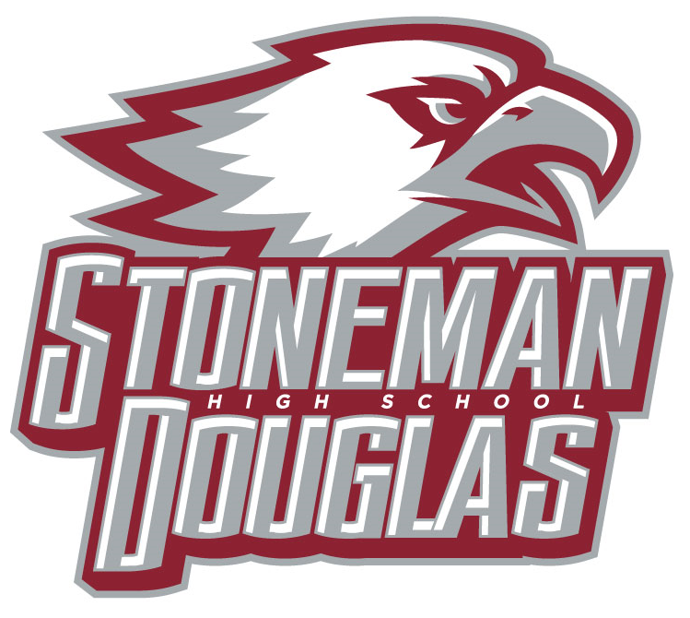

**Meeting Minutes**

**Date:** September 4, 2024

**Time:** 3:15 PM

**Location:** Media Center

1. Welcome/Call to Order/ Review of Agenda- 3:15
2. Attendance
3. Revision/Approval of May 2024 SAC minutes- Motion Mayersohn, Second Wanamaker (3:16)
4. SAC Voting:
   1. Parent slate, August 20, 2024 during Open House: passed
      1. Nominations from the floor of additional members: Becky Leung, Kelly Reda, Michael Goldberg, Vincent Cuillo, and Sue Atschul, unanimous approval
   2. Teacher slate, August 5, 2024 during Planning: passed
      1. SAC Co-Chairs and secretary elections- completed in May- Motion Mayersohn, Second Leung, unanimous approval (3:22)
   3. SAC positions for 2024-2025
   4. BTU – Melissa Falkowski
   5. Community/Business- Mayersohn
   6. ESE- Jacqui Luscombe
   7. ESOL- ?
   8. Gifted- Becky Leung
   9. I_Zone- Elisha Johnson
   10. Non- Instructional- Debra Wanamaker
   11. Student- Vincent Cuillo
   12. SAF chair- Elish Johnson and Becky Leung

-Motion Mayersohn, Second Leung, unanimous approval (3:22)

* 1. SAC By-Laws
     1. Motion Mayersohn, Second Rubenstein, unanimous approval (3:23)

1. Meetings dates for 2024-2025

September 4, 2023 at 3:15 pm in Media Center (Elect parent officers)

October 2, 2023 (SIP Review of goals and possible A+ voting

December 4, 2023 ( A+ voting, PSD and Exam Exemption Waiver updates or discussions)

January 22, 2024 (PSD and Exam Exemption Continuation Waiver Discussions)

March 5, 2024 (Exam Exemption continuation waiver vote and PSD continuation waiver vote)

April 2, 2024 (SPBP vote, create a nominating committee)

May 7, 2024( Election for 2025-2026 SAC Co-Chairs and Secretary)

1. Principal’s Report- Kefford, 3:24 to 3:45
   1. SESIR, updates are based on prior SAC meeting
      1. Alcohol = 1 (+0)
      2. Drug Possession/Use = 6 (+2)
      3. Fighting = 5 (+2)
      4. Larceny/Theft = 2 (+0)
      5. Physical Attack = 3 (+0)
      6. Sex Offenses = 1 (+1)
      7. Tobacco = 20 (+5)
      8. Other Major Offenses = 1 (+0)
2. Officers’ Report
   1. School Improvement Plan (SIP): SIP plan is being worked on due September 30th
   2. School-wide Positive Behavior Plan (SPBP): Monthly updates- Johnson report on reward system, “Catch Them Being Great” and the “Wheel of Prizes”- 3:48
   3. SAC School Accountability Funds: $62506- State has not increased funds in three years; Update on Delta Math and AICE; Department Head Meetings are being use as a forum to communicate availability of funds and possible uses in coordination in with SIP- 3:49
3. Special orders/unfinished business from previous meeting
   1. New business- No new items (3:50)

Announcements/Reminder:

Next meeting: October 2, 2024 at 3:15 pm in the media center

1. Adjournment- Motion Mayersohn, Second Rubenstein, unanimous approval (3:51)